Кроссворд «В мире космоса»

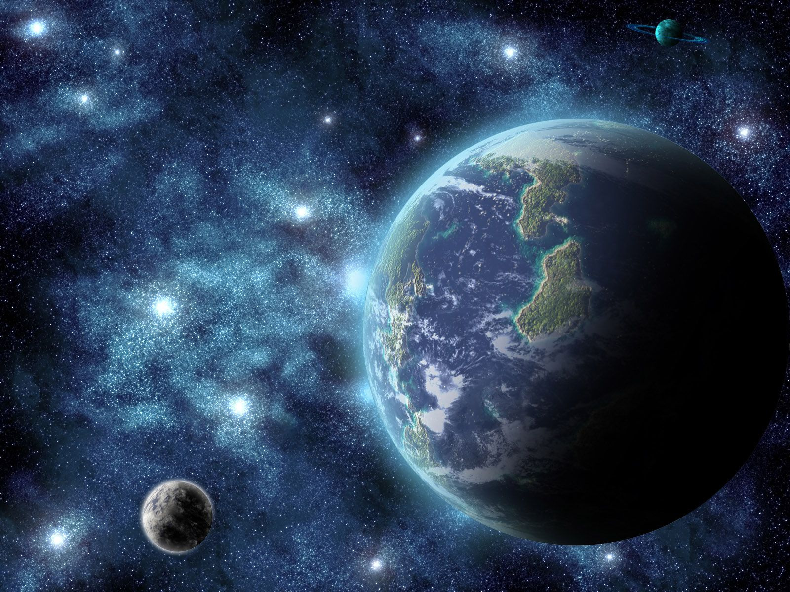

|  |  |  |  |  |  |  |  |  |  |  |  |  |  |  |  |  |  |  |  |  |  |  |  |  |  |  |  |  |  |  |  |  |  |  |  |  |  |  |  |  |  |  |  |  |  |  |  |  |  |  |  |  |  |  |  |  |  |  |  |  |  |  |  |  |  |  |  |  |  |  |  |  |  |  |  |  |  |  |  |  |  |  |  |  |  |  |  |  |  |  |  |  |  |  |  |  |  |  |  |  |  |  |  |  |  |  |  |  |  |  |  |  |  |  |  |  |  |  |  |  |  |  |  |  |  |  |  |  |  |  |  |  |  |  |  |  |  |  |  |  |  |  |  |  |  |  |  |  |  |  |  |  |  |  |  |  |  |  |  |  |  |  |  |  |  |  |  |  |  |  |  |  |  |  |  |  |  |  |  |  |  |  |  |  |  |  |  |  |  |  |  |  |  |  |  |  |  |  |  |  |  |  |  |  |  |  |  |  |  |  |  |  |  |  |  |  |  |  |  |  |  |  |  |  |  |  |  |  |  |  |  |  |  |  |  |  |  |  |  |  |  |  |  |  |  |  |  |  |  |  |  |  |  |  |  |  |  |  |  |  |  |  |  |  |  |  |  |
| --- | --- | --- | --- | --- | --- | --- | --- | --- | --- | --- | --- | --- | --- | --- | --- | --- | --- | --- | --- | --- | --- | --- | --- | --- | --- | --- | --- | --- | --- | --- | --- | --- | --- | --- | --- | --- | --- | --- | --- | --- | --- | --- | --- | --- | --- | --- | --- | --- | --- | --- | --- | --- | --- | --- | --- | --- | --- | --- | --- | --- | --- | --- | --- | --- | --- | --- | --- | --- | --- | --- | --- | --- | --- | --- | --- | --- | --- | --- | --- | --- | --- | --- | --- | --- | --- | --- | --- | --- | --- | --- | --- | --- | --- | --- | --- | --- | --- | --- | --- | --- | --- | --- | --- | --- | --- | --- | --- | --- | --- | --- | --- | --- | --- | --- | --- | --- | --- | --- | --- | --- | --- | --- | --- | --- | --- | --- | --- | --- | --- | --- | --- | --- | --- | --- | --- | --- | --- | --- | --- | --- | --- | --- | --- | --- | --- | --- | --- | --- | --- | --- | --- | --- | --- | --- | --- | --- | --- | --- | --- | --- | --- | --- | --- | --- | --- | --- | --- | --- | --- | --- | --- | --- | --- | --- | --- | --- | --- | --- | --- | --- | --- | --- | --- | --- | --- | --- | --- | --- | --- | --- | --- | --- | --- | --- | --- | --- | --- | --- | --- | --- | --- | --- | --- | --- | --- | --- | --- | --- | --- | --- | --- | --- | --- | --- | --- | --- | --- | --- | --- | --- | --- | --- | --- | --- | --- | --- | --- | --- | --- | --- | --- | --- | --- | --- | --- | --- | --- | --- | --- | --- | --- | --- | --- | --- | --- | --- | --- | --- | --- | --- | --- | --- | --- | --- | --- | --- | --- | --- | --- | --- | --- | --- | --- | --- | --- | --- | --- |
|  | |  |  |  |  |  |  |  |  |  |  |  |  |  | | --- | --- | --- | --- | --- | --- | --- | --- | --- | --- | --- | --- | --- | |  |  |  |  |  |  | **1** |  |  |  |  |  |  | |  |  |  |  |  |  |  |  |  |  |  |  |  | |  |  |  |  |  |  |  |  |  |  |  |  |  | |  |  |  |  |  | **32** |  | **4** |  |  |  |  |  | |  |  |  |  |  |  |  |  |  |  |  |  |  | |  |  |  |  |  |  |  |  |  |  |  |  |  | |  |  |  |  |  |  |  |  |  |  |  |  |  | |  |  |  |  |  |  |  |  |  |  |  |  |  | |  |  |  |  |  | **5** |  |  |  |  |  |  |  | |  |  |  |  | 6 |  |  |  |  |  |  |  |  | |  |  |  |  | 7 |  |  |  |  |  |  |  |  | |  |  |  | 8 |  |  |  |  |  |  |  |  |  | |  |  |  | 9 |  |  |  |  |  |  |  |  |  | |  |  | 1110 |  |  |  |  |  |  |  |  |  |  | |  |  | 12 |  |  |  |  |  |  |  |  |  |  | |  | 13 |  |  |  |  | **14** |  |  |  |  |  |  | |  | 15 |  |  |  |  |  |  | 16 |  |  |  |  | | 17 |  |  |  |  |  | 18 |  |  |  |  | | 19 |  |  |  |  |  | 20 |  |  |  |  | | | | | | |  |  |  | |  |  | | | | | |  | |  |  |  |  |  |
|  |  | | |  |  |  |  |  | | | |  | | |  |  |  |  |  | |

|  |  |  |  |  |  |  |  |  |  |  |  |  |
| --- | --- | --- | --- | --- | --- | --- | --- | --- | --- | --- | --- | --- |
|  |  |  |  |  |  | **1** |  |  |  |  |  |  |
|  |  |  |  |  |  |  |  |  |  |  |  |  |
|  |  |  |  |  |  |  |  |  |  |  |  |  |
|  |  |  |  |  | **32** |  | **4** |  |  |  |  |  |
|  |  |  |  |  |  |  |  |  |  |  |  |  |
|  |  |  |  |  |  |  |  |  |  |  |  |  |
|  |  |  |  |  |  |  |  |  |  |  |  |  |
|  |  |  |  |  |  |  |  |  |  |  |  |  |
|  |  |  |  |  | **5** |  |  |  |  |  |  |  |
|  |  |  |  | **6** |  |  |  |  |  |  |  |  |
|  |  |  |  | **7** |  |  |  |  |  |  |  |  |
|  |  |  | **8** |  |  |  |  |  |  |  |  |  |
|  |  |  | **9** |  |  |  |  |  |  |  |  |  |
|  |  | **1110** |  |  |  |  |  |  |  |  |  |  |
|  |  | **12** |  |  |  |  |  |  |  |  |  |  |
|  | **13** |  |  |  |  | **14** |  |  |  |  |  |  |
|  | **15** |  |  |  |  |  |  | **16** |  |  |  |  |
| **17** |  |  |  |  |  | **18** |  |  |  |  |
| **19** |  |  |  |  |  | **20** |  |  |  |  |

**Вопросы:**

**По горизонтали:**

2. Зодиакальное созвездие Северного полушария неба.

5. Орбитальная космическая станция, затопленная в 2001 году в Тихом океане.

6. Наша родная и любимая планета.

7. Ночью на небе один

Есть серпастый господин.

Пролетели две недели

Господин наш стал полнее.

8. Небесное тело, которое обращается по орбите вокруг Солнца.

9.  Поверхностный слой сыпучего [лунного](https://ru.wikipedia.org/wiki/%D0%9B%D1%83%D0%BD%D0%B0) грунта

10.Американский астронавт, впервые ступивший на поверхность Луны.

12. Гравитационное взаимодействие.

13. Самая отдалённая от Солнца планета.

14. Планета гигант.

15. Красная планета.

16. Этот астероид назван в честь римского бога любви.

17. Небесная …

18. Направление, совпадающее с направлением действия [силы гравитации](https://ru.wikipedia.org/wiki/%D0%93%D1%80%D0%B0%D0%B2%D0%B8%D1%82%D0%B0%D1%86%D0%B8%D1%8F) в данной точке.

19.Авиаконструктор под руководством, которого запущен первый в мире искусственный спутник Земли и космический корабль с первым космонавтом.

20.Точка на небесной сфере, в которую направлен вектор скорости движения наблюдателя.

**По вертикали:**

1. Быстрее птицы к звёздам нас домчит.

3. Единственный естественный спутник Земли.

4. Зодиакальное созвездие царя животных.

11. Спутник Сатурна, открыт в 1980 г. американскими учёными.



|  |  |  |  |  |  |  |  |  |  |  |  |  |
| --- | --- | --- | --- | --- | --- | --- | --- | --- | --- | --- | --- | --- |
|  |  |  |  |  |  | **1Р** |  |  |  |  |  |  |
|  |  |  |  |  |  | **А** |  |  |  |  |  |  |
|  |  |  |  |  |  | **К** |  |  |  |  |  |  |
|  |  |  |  |  | **32Л** | **Е** | **4В** |  |  |  |  |  |
|  |  |  |  |  | **У** | **Т** | **Е** |  |  |  |  |  |
|  |  |  |  |  | **Н** | **А** | **С** |  |  |  |  |  |
|  |  |  |  |  | **А** |  | **Ы** |  |  |  |  |  |
|  |  |  |  |  |  |  |  |  |  |  |  |  |
|  |  |  |  |  | **5М** | **И** | **Р** |  |  |  |  |  |
|  |  |  |  | **6З** | **Е** | **М** | **Л** | **Я** |  |  |  |  |
|  |  |  |  | **7М** | **Е** | **С** | **Я** | **Ц** |  |  |  |  |
|  |  |  | **8П** | **Л** | **А** | **Н** | **Е** | **Т** | **А** |  |  |  |
|  |  |  | **9Р** | **Е** | **Г** | **О** | **Л** | **И** | **Т** |  |  |  |
|  |  | **1110А** | **Р** | **М** | **С** | **Т** | **Р** | **О** | **Н** | **Г** |  |  |
|  |  | **12Т** | **Я** | **Г** | **О** | **Т** | **Е** | **Н** | **И** | **Е** |  |  |
|  | **13П** | **Л** | **У** | **Т** | **О** | **14Н** | **Е** | **П** | **Т** | **У** | **Н** |  |
|  | **15М** | **А** | **Р** | **С** |  |  |  | **16А** | **М** | **У** | **Р** |  |
| **17М** | **А** | **Н** | **Н** | **А** |  | **18Н** | **А** | **Д** | **И** | **Р** |
| **19Т** | **И** | **Т** | **О** | **В** |  | **20А** | **П** | **Е** | **К** | **С** |

|  |  |  |  |  |  |  |  |  |  |  |  |  |
| --- | --- | --- | --- | --- | --- | --- | --- | --- | --- | --- | --- | --- |
|  |  |  |  |  |  | **1Р** |  |  |  |  |  |  |
|  |  |  |  |  |  | **А** |  |  |  |  |  |  |
|  |  |  |  |  |  | **К** |  |  |  |  |  |  |
|  |  |  |  |  | **32Л** | **Е** | **4В** |  |  |  |  |  |
|  |  |  |  |  | **У** | **Т** | **Е** |  |  |  |  |  |
|  |  |  |  |  | **Н** | **А** | **С** |  |  |  |  |  |
|  |  |  |  |  | **А** |  | **Ы** |  |  |  |  |  |
|  |  |  |  |  |  |  |  |  |  |  |  |  |
|  |  |  |  |  | **5М** | **И** | **Р** |  |  |  |  |  |
|  |  |  |  | **6З** | **Е** | **М** | **Л** | **Я** |  |  |  |  |
|  |  |  |  | **7М** | **Е** | **С** | **Я** | **Ц** |  |  |  |  |
|  |  |  | **8П** | **Л** | **А** | **Н** | **Е** | **Т** | **А** |  |  |  |
|  |  |  | **9Р** | **Е** | **Г** | **О** | **Л** | **И** | **Т** |  |  |  |
|  |  | **1110А** | **Р** | **М** | **С** | **Т** | **Р** | **О** | **Н** | **Г** |  |  |
|  |  | **12Т** | **Я** | **Г** | **О** | **Т** | **Е** | **Н** | **И** | **Е** |  |  |
|  | **13П** | **Л** | **У** | **Т** | **О** | **14Н** | **Е** | **П** | **Т** | **У** | **Н** |  |
|  | **15М** | **А** | **Р** | **С** |  |  |  | **16А** | **М** | **У** | **Р** |  |
| **17М** | **А** | **Н** | **Н** | **А** |  | **18Н** | **А** | **Д** | **И** | **Р** |
| **19Т** | **И** | **Т** | **О** | **В** |  | **20А** | **П** | **Е** | **К** | **С** |

Использовала картинку- http://anthropos.org.ua/wp-content/uploads/2012/11/111.jpg