Я -
расту






 |  |  | 150
 |  | 149
 |  | 148
 |  | 147
 |  | 146
 |  | 145
 |  | 144
 |  | 143
 |  | 142
 |  | 141 | 140
 |  | 139
 |  | 138
 |  | 137
 |  | 136
 |  | 135
 |  | 134
 |  | 133
 |  | 132
 |  | 131
 |  |  | 130
 |  | 129
 |  | 128
 |  | 127
 |  | 126
 |  | 125
 |  | 124






 |  | 123
 |  | 122
 |  | 121 | 120
 |  | 119
 |  | 118
 |  | 117
 |  | 116
 |  | 115
 |  | 114
 |  | 113
 |  | 112
 |  | 111 | 110
 |  | 109
 |  | 108
 |  | 107
 |  | 106
 |  | 105
 |  | 104
 |  | 103
 |  | 102
 |  | 101
 |  |  | 100
 |  | 99
 |  | 98
 |  | 97



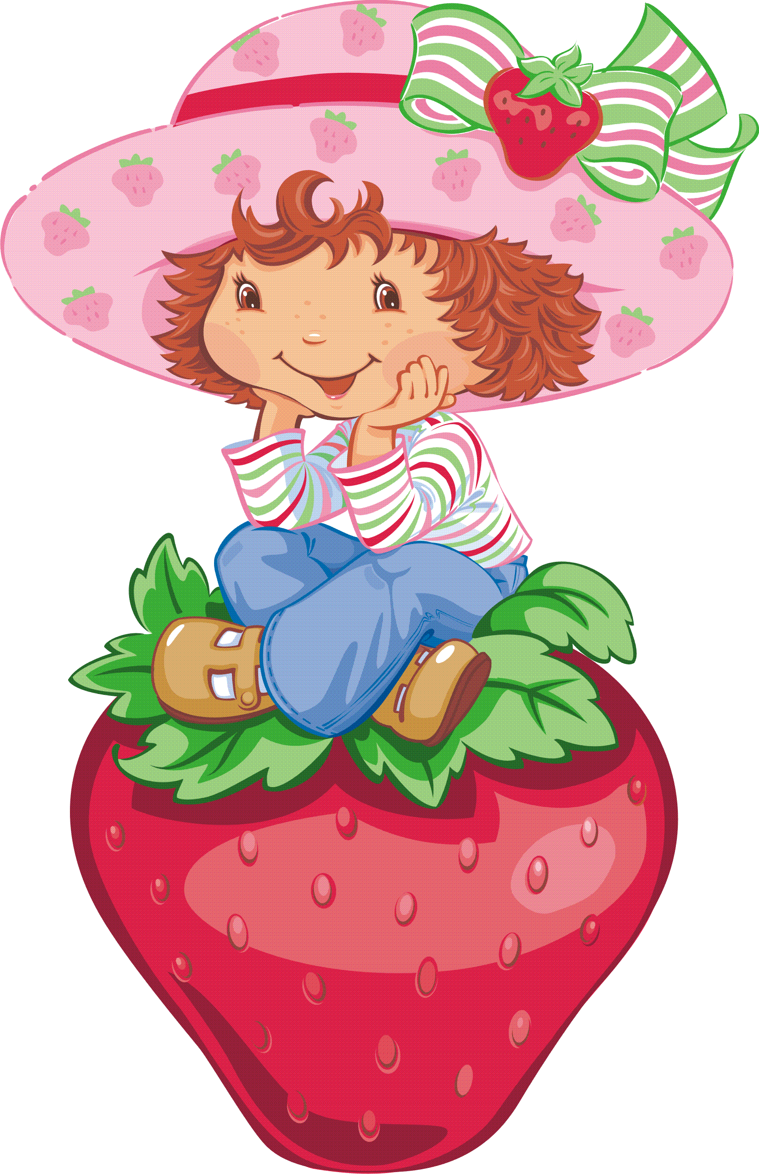

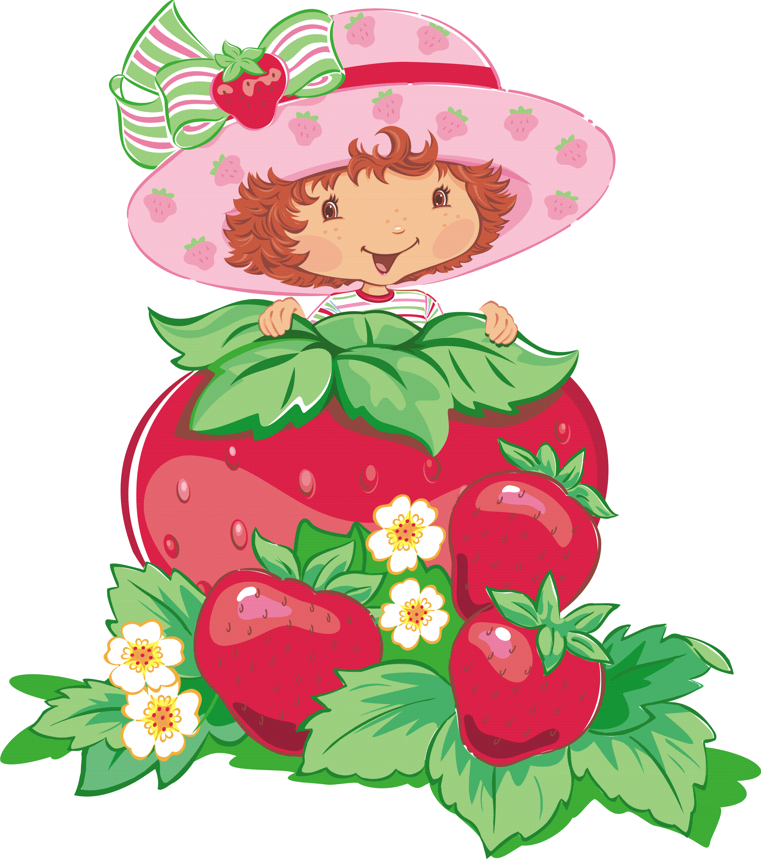
 |  | 96
 |  | 95
 |  | 94
 |  | 93
 |  | 92
 |  | 91 | 90
 |  | 89
 |  | 88
 |  | 87
 |  | 86
 |  | 85
 |  | 84
 |  | 83
 |  |  | http://pochemu4ka.ru/
 |  | 82
 |  | 81
 |  |  | 80
 |  | 79
 |  | 78
 |  | 77
 |  | 76
 |  | 75
 |  | 74
 |  | 73
 |  | 72
 |  | 71 | 70

