***Кроссворд для детей 5-6 лет на тему:"Профессии"***

***(Нарисуй в пустом квадрате, кем ты хочешь стать, когда вырастишь)***

|  |  |  |  |  |  |  |  |  |
| --- | --- | --- | --- | --- | --- | --- | --- | --- |
|  |  | ***3.*** |  |  |  |  | ***8.*** | ***9.*** |
|  |  |  | ***4.*** | ***5.*** | ***6.*** |  |  |  |
|  | ***2.*** |  |  |  |  |  |  |  |
| ***1. П*** | ***Р*** | ***О*** | ***Ф*** | ***Е*** | ***С*** | ***7.С*** | ***И*** | ***Я*** |
|  |  |  |  |  |  |  |  |  |
|  |  |  |  |  |  |  |  |  |
|  |  |  |  |  |  |  |  | ***http://ds310.ru/uploads/userfiles/images/povar.jpg***  1 |
|  |  |  |  |  |  |  |  |  |
|  |  |  |  |  |  |  |  |  |

|  |  |  |  |  |  |  |  |  |
| --- | --- | --- | --- | --- | --- | --- | --- | --- |
|  |  |  |  |  |  |  |  |  |

|  |  |  |  |  |  |  |  |  |
| --- | --- | --- | --- | --- | --- | --- | --- | --- |
|  |  |  |  |  |  |  |  |  |

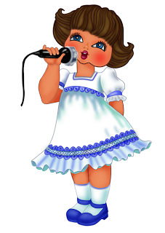

|  |
| --- |
|  |

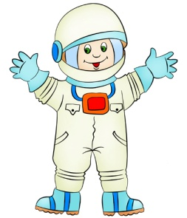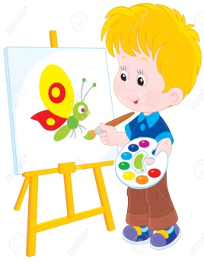

6

2

3

9

8

7

5

4

6